**Chess Project Specification**

**General**

The project is a chess game (according to all of the standard chess rules), that can be played locally against another player, or against a bot.

Project’s target audience is anyone who wants to play chess on his PC, without any hassle, as the project provides a chess game that can be played with ease:

The game doesn’t require an online connection (or physical pieces and board) to play, and doesn’t require a second player to play against, by providing a chess playing bot. Additionally the game has a built in clock, allowing a timed game, without a timer.

**Design**

**Main Menu**

The screen that the user sees after launching the game.

**Buttons**:

**Play** -Starts the game with the current game options.

**Game options** -Takes the user to the to the game options window.

**Settings** - Takes the user to the settings menu window.

**Quit** - Exits the game.

The buttons are placed in the middle of the screen, under the game's logo (which is shown in the next image at the top).

The main menu will have a special background, separate from other screens with basic one-color backgrounds.

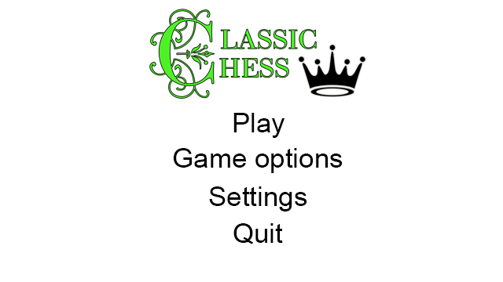

**Game options**

Options for the next chess game. These options only define the game settings for the next chess game (not graphical/technical settings).

All of the game options will be saved after any change, and used the next time the 'Play' button is clicked from the main menu (or ‘Start game’ button from game options).

**Buttons**:

**Opponent** - Radio buttons that allow for selecting either a player (local play) or a bot (ai).

Default selection is player (local play).

**Variant** - Dropdown selection for chess variants. All of the available chess variants follow the standard chess rules, except the starting position in the game.

Dropdown options:

Standard, Chess960 (randomized), ...

Default selection is Standard.

**Clock time -** Dropdown selection for clock time options. The time selected will be given to each player, if the player's time runs out - he loses.

There is an option to select no time limit, or a custom time (that will be inputted by the user into the field).

Dropdown options:

No limit, 1/2, 1, 3, 5, 10, 30, 60, Custom

Default selection is No limit.

**Time increment** - Dropdown Selection for time increment after each move by the player. After making a move, player’s time clock is increased by this value. Not shown if Clock time setting is set to 'No limit'.

Dropdown options are from 0 to 10 (seconds), and an option to set a custom time increment, just as with the clock time.

Default selection is 0.

**Color** - Dropdown selection of the player's color in the game. Only available and shown when opponent selected is a bot.

Dropdown options:

Random, White, Black

Default selection is Random.

**Back** - Closes the game options window (can also be activated by pressing escape).

Each one of the buttons described is placed one after another, except the 'back' button, which is placed to the left of the 'start game' button.

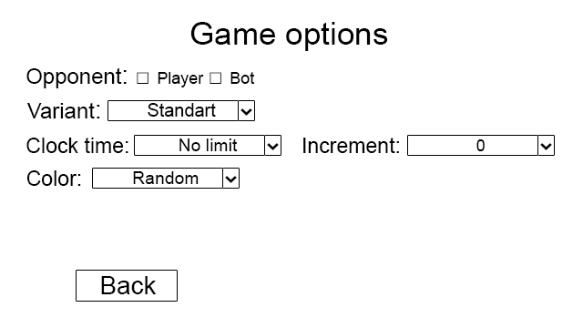

**Settings menu**

Screen for the technical settings for the game, accessed from the main menu.

All of the settings are saved and applied only after hitting the 'Apply' button (or if the user goes back and chooses the apply settings button).

**Buttons**:

**Fullscreen** -On/Off button which determines if the game runs in full-screen or in windowed mode.

Default mode is on.

**Resolution** -Dropdown selection of resolutions.

Default resolution is the native resolution of the user's monitor.

**Square colors** - Two buttons for light and dark square colors, the buttons are of the current square color, upon pressing will open a color selection window which can change their color.

Default values: white as light square color, black as dark square color.

**Flip board after a move** - On/Off button which determines if the game board flips (turns 180 degrees) visually, after each move in the game (only in games with two players).

Default value is on.

**Apply** - Applies and saves the changes to the settings.

**Back** - Returns the user to the main menu screen. The key esc will have the same function.

If settings were changed but not applied, and back was pressed, a small window will pop up asking the user if he is sure he wants to go back to main menu. The window will have 3 buttons in the middle:

**1)** Yes, apply settings **2)** Yes, don’t apply settings **3)** No

In addition to the buttons, there is a **volume** **slider** from 0 to 100.

Default volume value is 50.

The setting buttons and the volume slider are positioned in the middle of the screen. The 'Apply' and 'Back' buttons are positioned at the lower-right corner of the screen.

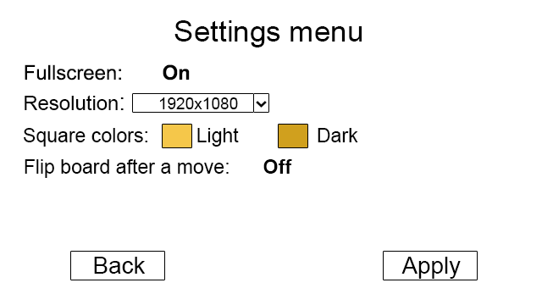

*(Non-default square colors for an example)*

**Game screen**

The screen of the chess game.

The game screen contains the game board at the middle of the screen. If played against a bot, the board will be positioned in a way so the player's pieces are at the bottom of the board.

If played against a player, the board will start with the pieces being at the bottom of the board. The board will flip after each move, if the relevant setting is set to 'Yes'.

Above and below the board for each player, small icons of pieces captured by the player, but not by the other player, will be shown.

Upon the player clicking on his chess piece, the square of the piece is highlighted, and possible move squares for the piece are also highlighted, with a different color.

If, after selecting his piece, the player selects a valid move, the move is done and his turn is over. If the player presses anywhere else on the screen, the piece selection is undone (and all the highlights are too).

After a move, the last and current positions of the piece moved are highlighted.

If the game is played with time limits, there is a clock for each player, on the right side of the board. If not - no clock is shown.

**Buttons**:

**Resign** - Brings up a window asking if the player is sure to resign. Resigns and ends the game once if the player chooses to.

**Offer draw** - If played locally against a player, a similar window to the previous one will be opened, asking the player if he is sure to draw (since the game is played on the same pc).

If the game is played against a bot, the bot will accept a draw only if his game evaluation is close to being equal, or if he is losing.

Ends the game with a draw if the other side agrees to it.

**Quit to main menu** - Quits to the main menu. If pressed after both of the players have moved, a new window will ask if the user is sure that he wants to stop the match and quit. Can also be activated by the escape button.

Upon the completion of the game a new window will pop, telling the game's result (e.g. 1-0 White wins by checkmate). Additionally, the window contains two buttons:

**Rematch** - Starts a new game, having the exact same game settings as the completed match.

**Quit to main menu** - Quits to the main menu.

Resign and offer draw buttons will be positioned at the bottom of the screen. Quit to main menu button will be positioned at the top-right part of the screen.

The window after completion of the screen, or the windows asking the user if he's sure, will be opened in the middle of screen (on top of the game screen).

